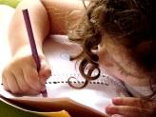  Literacy and WCR  In Talk 4 Writing, this half term, Year 3 will be exploring a traditional Chinese morality story; The Magic Brush. We will be writing our own Magic Brush story focusing on the key literary devices to help set the scene and build the tension. We will then write an explanation text; How a magic brush works.  Year 3 will be reading “The Pebble in My Pocket” and “The Firework-maker’s Daughter” from Pie Corbett’s reading spine. | Maths  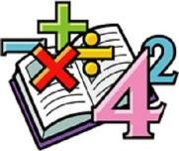  In Maths, we will continue looking measuring length and perimeter.  We will continue to develop our arithmetic skills to which we can apply to help us solve problems.  We will continue to complete daily times tables practise. | Science    In Science, this half-term, we will be look at the topic Plants.  We will look closely at the different parts of a plant and what their roles are. We will be setting up an investigation to explore what plants need for life and growth and we will explore the part that flowers play in the life cycle of flowering plants. | Computing  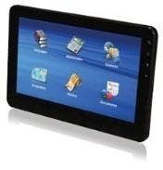  In Computing, Year 3 will be.  learning to recognize basic inputs and outputs.  To decompose a laptop.  To understand the purpose of computer parts.  To decompose a tablet computer.
  Humanities  In Geography, Year 3 will be focusing on the volcanoes and earthquakes. We will be learning: what you find under the Earth’s surface; the stages of a volcano's life cycle; why people, live in the vicinity of volcanoes; what causes earthquakes and how they are measured. | Overdale Community Primary School  Year 3 Spring 2 – 2025  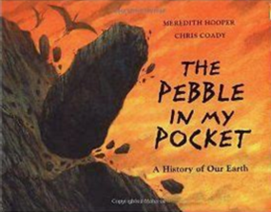  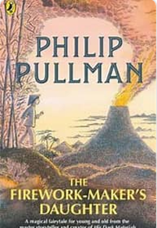 |  | 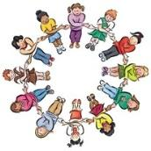  RHE/PSHE  This term in PSHE, Year 3 will be looking at the choices we make and how they are influenced.  We will also look at aspects of citizenship including our rights and responsibilities and local issues including charity and recycling.
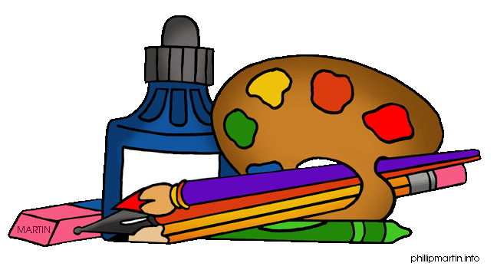  Art and DT  In DT we will be learning about Mechanical systems and Pneumatic toys  To understand how pneumatic systems work. To design a toy that uses a pneumatic system  To create a pneumatic system.  To test and finalise ideas against design criteria. |   PE  This term in PE, Year 3 will be honing our football skills with the help of specialist football coaches from Hawkes Health. |   French In French, we will be learning to follow classroom instructions in french and to name items of stationery found in the classroom  Music  In Music, the focus will be exploring the pentatonic scale. Year 3 will be play, perform improvise and explore music linked to Chinese New Year with the support our music specialist Mrs Leggitt. |   RE  In RE this half term, we will be looking at the key question. “Why are festivals important to religious communities?”  We will look at what is worth celebrating?  Why Divali is significant to Hindus.  Why Muslims celebrate Ramadan.  Why Jewish people celebrate Pesach.  What do Christians celebrate at Easter?

Reading: Children will be expected to read their home reading books three times a week with a written comment from a parent in their reading record. Books will be changed when children complete a book review of their current reading book or in a phonic session.
Maths: Children will be tested on their times tables throughout the week as well as a weekly arithmetic test to build their mental arithmetic confidence.
Homework: Year 3 have been given homework book with weekly tasks to complete that relate to learning that has been delivered during the week. Year 3 will have a maths task, spelling/handwriting task and a foundation subject task to complete. This is handed out every Friday and is expected to be returned by the following Friday.

